PROJECT REPORT TEMPLATE

INTRODUCTION :

OVERVIEW :

Create and manage vehicle records to optimize the usage of your trucks and trailers that carry inventories to stores. To track the vehicle that carry goods out of a warehouse, assign them to that warehouse.

PURPOSE :

Vehicle management is an appllication where a customer details are stored inorder to choose cars, bikes and commercial vehicles for travel with in the city. The data which is stored here is further used to remain them if any offers are provided during the seasons and any updates regarding vehicles are send to them in the form of message and mails.

EMPATHY MAP :

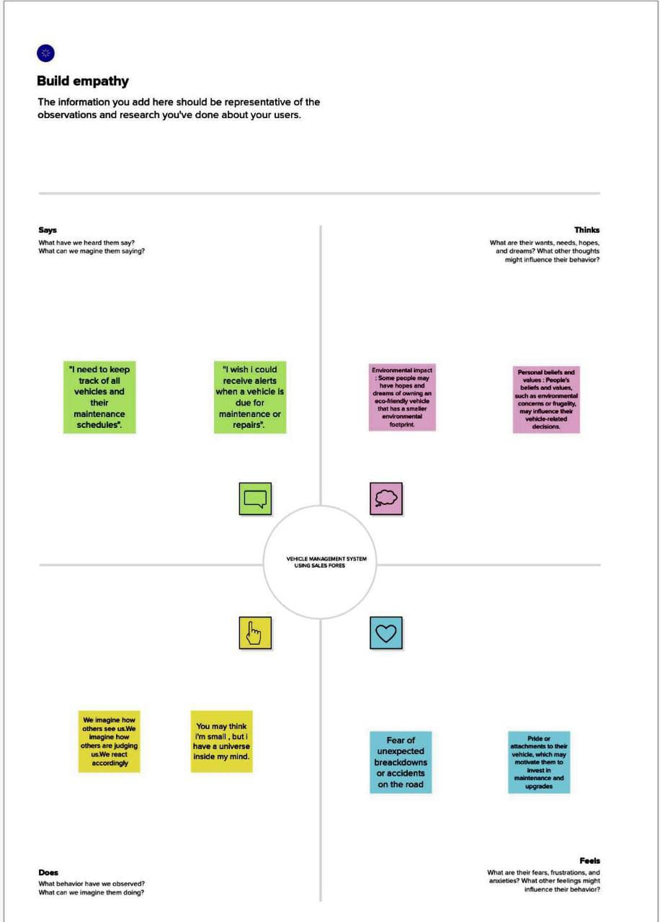

IDEATION & BRAINSTORMING MAP :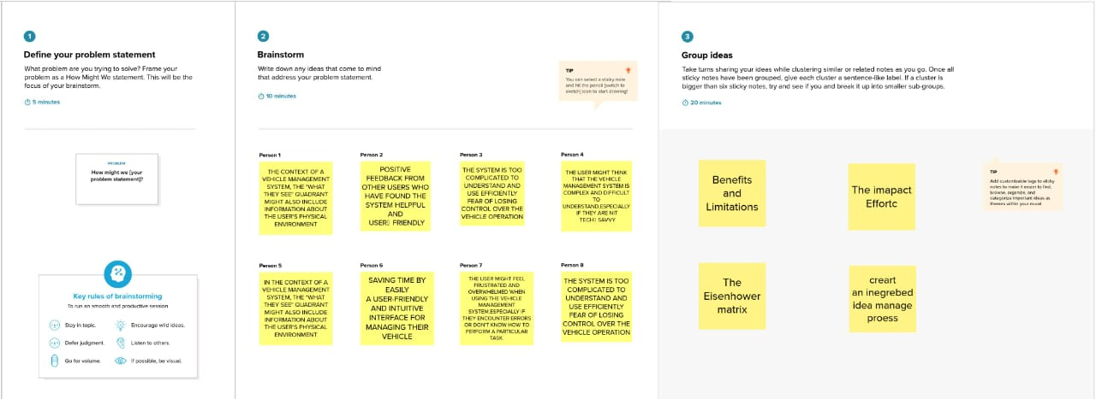 RESULT

DATA MODEL :

|  |  |  |
| --- | --- | --- |
| OBJECT NAME | FIELD IN THE OBJECT | |
| VEHICLE | FIELD LABEL | DATA TYPE |
| Customer Name | Text |
| Customer Mobile No | Number |
| VEHICLE TYPE  2Wheeler  4Wheeler | Picklist |

|  |  |  |
| --- | --- | --- |
| VEHICLE | 2WHEELERS  1)HERO  2)HONDA  3)BAJAJ  4)ROYAL ENFIELD  5)TVS  6)KINETIC  7)OLA  8)JAWA  9)SD  10)BATTERY | Picklist |
| 4WHEELERS  1)RENAULT  2)SKODA  3)HONDA  4)HYUNDAI  5)SUZUKI  6)MAHINDTRA  7)VOLKSWAGEN  8)BENZ  9)AUDI  10)VOLVO | Picklist |
| VEHICLE NAME | Text |
| VEHICLE NO | Text |
| CHASSIC NO | Text |
| COLOUR | Text |
| BODY TYPE | Text |
| MILEAGE | Text |

|  |  |  |
| --- | --- | --- |
| VEHICLE | VEHICLE INCLUDES  1)Fire Extenuation  2)First Aid Kit  3)Multi Charger Kit  4)Stepney  5)Stereo  6)Tool Kit  7)Tracking Device  8)Tyre Jack | Multi Picklist |
| CONDITION  1)Good  2)Medium  3)Least | Picklist |
| SEATS | Number |
| START DATE | Date/Time |
| END DATE | Date/Time |
| OPPORTUNITY | Lookup(Oppportunities) |

|  |  |  |
| --- | --- | --- |
| DRIVER | FIELD | DATA TYPE |
| DRIVER NAME | Text |
| LICENCE NO | Text |
| MOBILE NO | Number |
| FAIR PER HOUR | Text |
| VEHICLE | Lookup(Vehicle) |

ACTIVITY & SCREENSHOR :

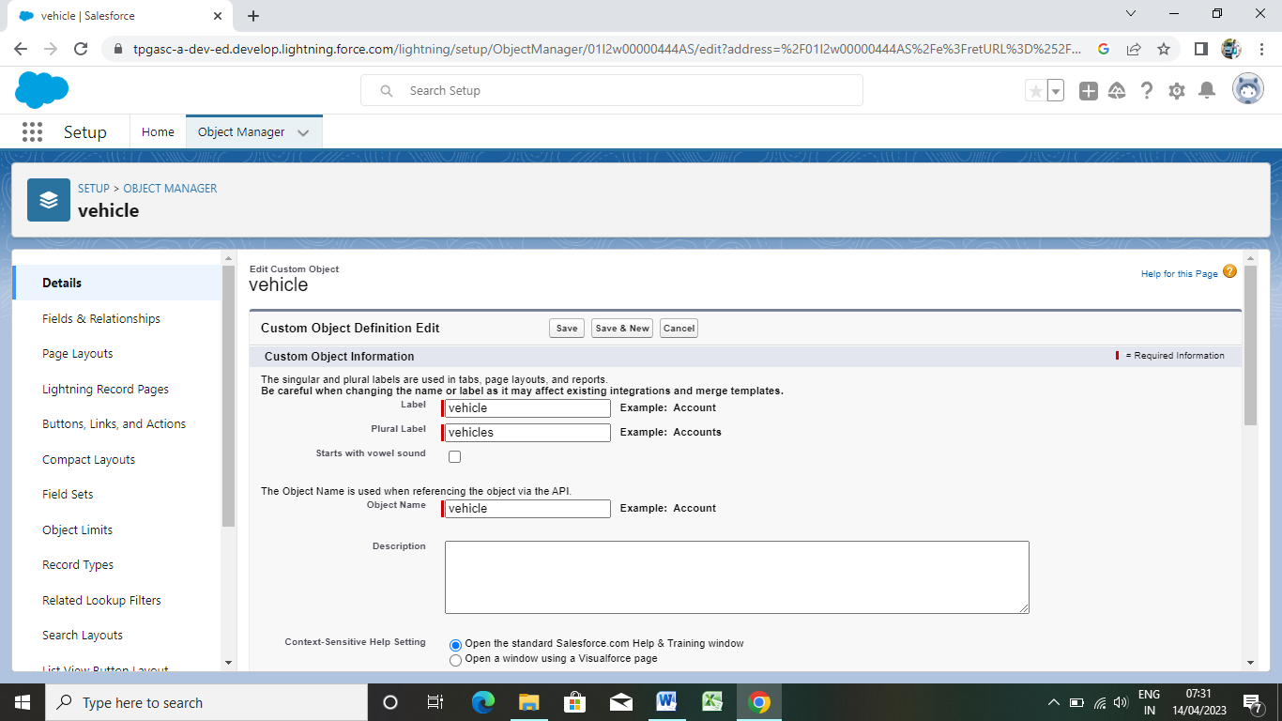

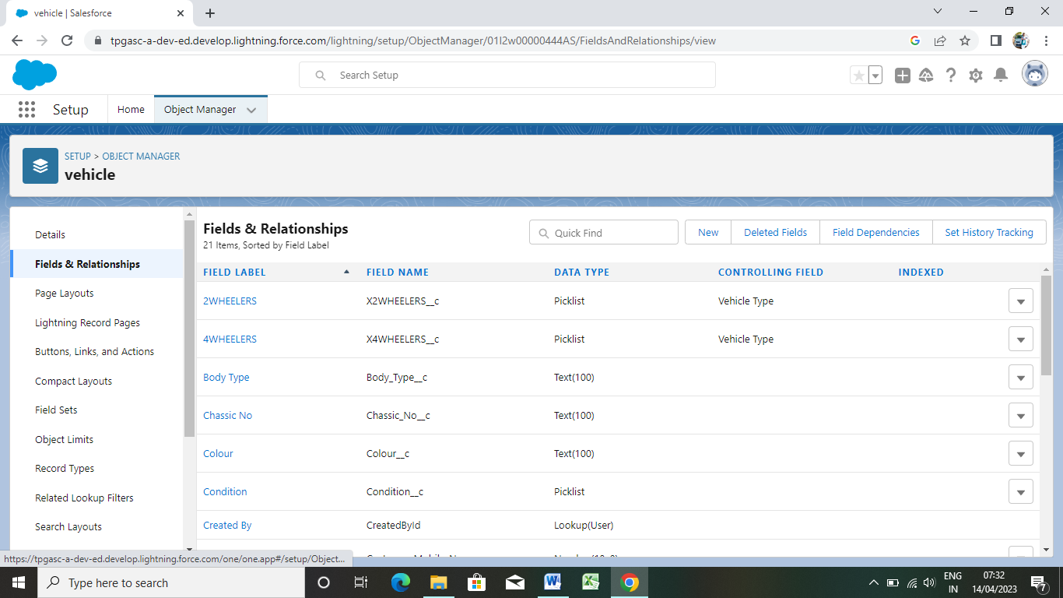

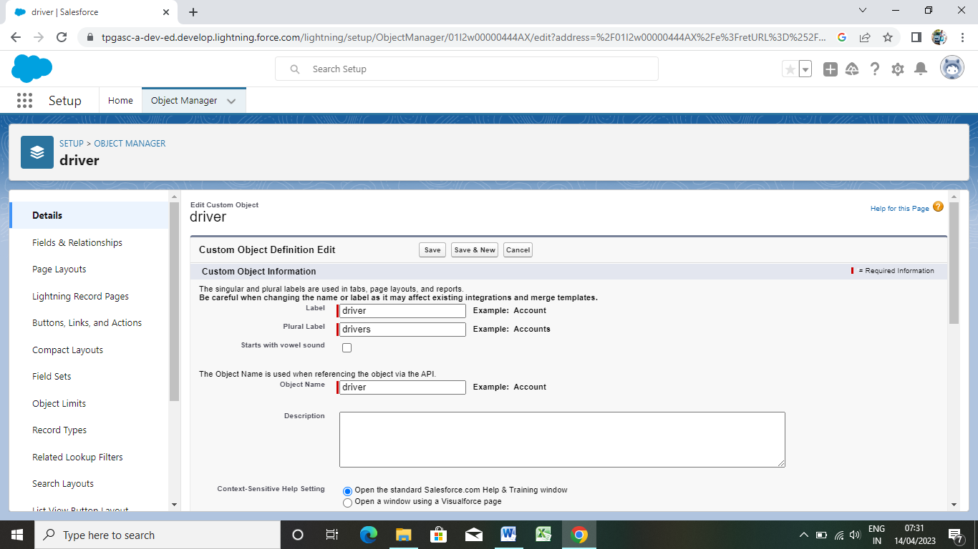

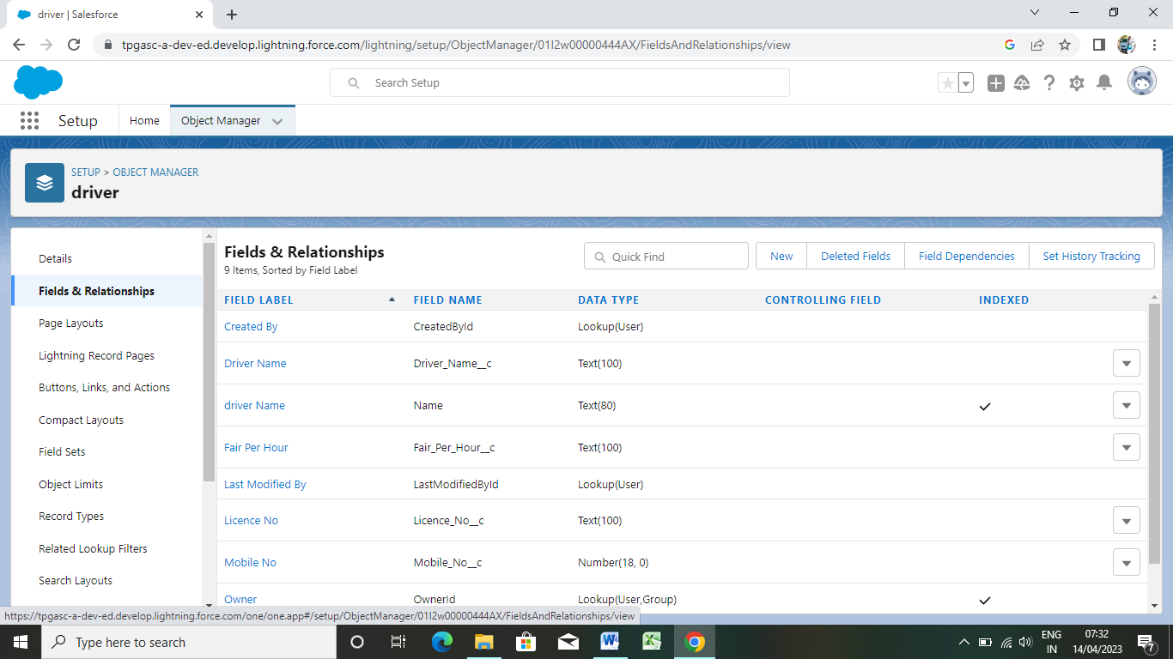

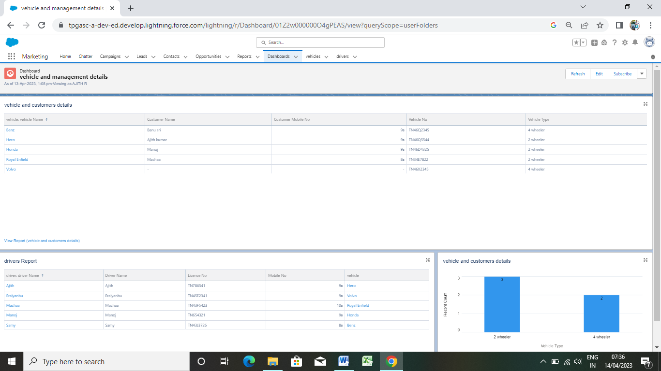

TRAILHEAD PROFILE PUBLIC URL :

Team Leader : https://trailblazer.me/id/ajithlaadan990

Team Member 1 : https://trailblazer.me/id/skumar9217

Team Member 2 : https://trailblazer.me/id/eeraiyanbu

Team Member 3 : https://trailblazer.me/id/manog58

Team Member 4 : https://trailblazer.me/id/akumar8262

ADVANTAGES & DISADVANTAGES :

Vehicle management features – advantages – benefits

Advantages – vehicle management. Duplication of the vehicle data is avoided. As vehicle number is already stored in the master therefore human mistakes can be avoided. Timely alerts ensure that penalties are avoided.

Active tracking based fleet management requires monthly subscription charges and data usage charges.

GPS Device used in fleet management is power hungry which drains battery faster.

APPLICATION :

The vehicle management system is an application for the automotive industry. It support in the area of sales and service the business processes that you require as vehicles importer when dealing with your original equipment manufacturers and your dealers in new and used vehicle sales.

CONCLUSION :

The main purpose for developing this project can helps to manage the customer details driver details etc.

FUTURE SCOPE :

By component: Solutions service

deployment type: on-premises cloud